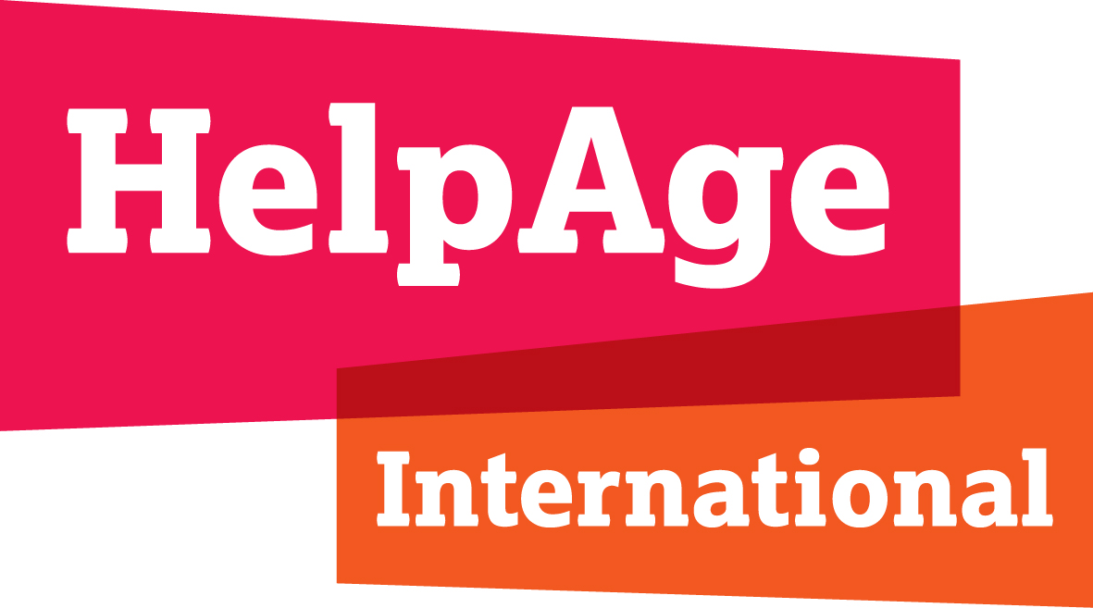

PRESS RELEASE
For immediate release: 26 March 2020

Coronavirus: Older people in low- and middle-income countries must be protected to prevent global humanitarian catastrophe

- Spokespeople available

Thousands, if not millions, of older people’s lives are at risk, if the coronavirus COVID-19 pandemic takes hold in low-and middle-income countries, particularly those in conflict and crisis. This would be a global catastrophe that could be averted if the right steps were taken now, HelpAge International said today.
“We have seen how countries with relatively developed health systems are buckling under the strain, so it’s easy to see how the coronavirus pandemic could rapidly develop from a global health crisis into a global humanitarian emergency in crisis and conflict settings. It is older people who are most at risk and who will bear the brunt of this unimaginable loss of lives,” said Justin Derbyshire, Chief Executive of HelpAge International.
Older people are already more susceptible to COVID-19 because of their weakened immune system and increased propensity for underlying health conditions, such as heart disease, diabetes or cancer. But older people living in such difficult conditions, with little access to food, water and health care, are extremely at risk.
“An outbreak of coronavirus in places like Idlib in Syria or Cox’s Bazaar in Bangladesh could spread like wildfire. This would be catastrophic for everyone affected, but particularly older people. We need a greater focus on protecting and informing older people by international aid agencies, and significantly increased resources.”
Measures to curb the spread of the COVID-19 outbreak, such as social distancing, public information and improved hygiene practices, are difficult enough in high-income countries. In places where there is severe overcrowding, lack of clean water and low levels of literacy, this will be an enormous challenge.
Health centres in conflict and crisis settings struggle to provide basic health care in normal circumstances. They are not currently equipped to respond to the demands that an outbreak of COVID-19 would create, with testing facilities, ventilators for treatment, and empty beds and rooms for isolation and quarantine. And the facilities and equipment to treat acute cases simply do not exist, or are very limited, in many of these settings.
In Idlib, in northern Syria, the problems are particularly acute. Thousands of older people have been displaced from their homes; they are exhausted, living in overcrowded and unhygienic conditions, often in the open air, and many have no access to even the most basic health care. According to the World Health Organisation, less than two-thirds of the country's hospitals were functioning at the end of 2019, while 70 percent of health workers had fled the country.
“It is absolutely vital that we have clear measures to support older people, such as ensuring that they can access important health information aimed at those who may be illiterate or have no mobile phones or computers. We must ensure that they have access to clean water, sanitation and food supplies when they may not be able to reach central aid points.”
Sub-Saharan Africa currently has more than 1,300 confirmed cases of COVID-19 and this is rising rapidly, especially in countries where there are large refugee populations and slums, such as Kenya, Uganda, Ethiopia and Tanzania.
A HelpAge network member in Kenya reported that self-isolation in Kibera (the largest urban slum in Africa) is almost impossible and most people have no access to clean water and soap, or decent health care.
Cox’s Bazaar, home to around one million mainly Rohingya refugees spread across 34 camps, recorded its first official case of Coronavirus this week. Older people in the camps are living in very difficult conditions and will be exposed to huge risk if the virus spreads through the camps as there is minimal capacity for treatment.
“People are living on top of each other with little access to information, nutritious food, health care, clean water and sanitation. There is a high risk that infection rates will soar if it is not controlled in the camps,” said Justin Derbyshire
If infection rates do soar in conflict and crisis settings, doctors will have to operate a triage system to decide how to allocate scarce medical resources to a large number of patients, which is a legitimate medical practice.

HelpAge is calling on the World Health Organisation to develop triage guidelines for governments ensuring that decisions are based on medical grounds, scientific evidence and ethical principles, rather than age or assumed social worth.
The organisation fears that older people are being discriminated against in the light of derogatory and dehumanising language being used in the media and on social media emphasising older people’s ‘vulnerability’ and messaging aimed at reassuring the wider population that devalues older people suggesting that ‘only’ older people are at risk of death.
A HelpAge network member in Kenya reported that older people coming to their centre said that they felt discriminated against and stigmatised and they worry that young people think that coronavirus is a good thing as it is ‘getting rid of older people’.
“Older people must not be stigmatised and treated as passive, weak victims who have no ability to exercise their own judgement,” said Justin Derbyshire.
HelpAge is calling on greater leadership from international bodies, such as the UN and the WHO, to recognise the significant risks faced by older people in low and middle-income countries to COVID-19 and to invest resources in protection for older people from the virus and providing the best possible treatment for those that do become ill.
“We must do everything we can to protect older people’s lives around the world. This virus has already killed far too many people and has led to an immeasurable level of suffering. We must prioritise low and middle-income countries now, to prevent this crisis from becoming a global humanitarian crisis, the like of which we have never seen before,” said Justin Derbyshire.
ENDS
Notes to Editor
HelpAge is working through its country offices and network members around the world, primarily focussing on communities living in lower income and fragile contexts, providing guidance and information to older people and putting in place measures to protect them. This includes community outreach and awareness campaigns and providing hygiene items such as soap, sanitisers, gloves and masks. We are also advocating for the effective inclusion of older people in humanitarian preparedness and response to COVID-19; and for practical recognition of older people’s needs and rights in the strategies and funding allocations of donor governments and agencies.

For more information and/or interviews please contact Louise Orton at louise.orton@helpage.org, tel: +44 (0)7939 141 764

