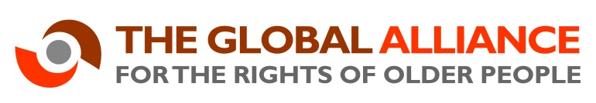

Global Alliance for the Rights of Older People (GAROP)
Member consultation meeting – Saturday 8th July 2017
AARP, 750 3rd Ave, New York, NY 10017 (between 46th and 47th street on 3rd Ave)
9:00am-1:00pm
Draft programme
Welcome and overview | - Welcome and introductions if necessary.  - This meeting is part of a wider consultation with GAROP members to ensure that the GAROP work plan through to the end of March 2018 meets the needs of its members.  - The main aims of this meeting are:  - To gather feedback from those GAROP members present on our core areas of work.  - To strengthen members’ ownership of and involvement in GAROP activities.
Maximising our added value | - What do members most want and need from GAROP? (Taking into account our mission, vision and values)  - Understanding our current membership.
Communicating better within GAROP | - How can we encourage more participation in information sharing across GAROP and between members?  - What is needed from members and the Secretariat to enable this?
Developing GAROP joint positions | - What do GAROP members need for agreeing joint positions?  - Gather ideas of key components of consultation mechanisms.  - Examples of successful joint position preparation from other networks.
Fundraising for our activities | GAROP activities may not continue beyond the end of March 2018 unless further funding is secured.  - How can further funding for GAROP activities be secured?  - What are members able to contribute, either in cash and in-kind?  - What activities should the Secretariat prioritise?  - Ideas on funding targets and pitches.
GAROP governance | The Interim Steering Group will disband at the end of March 2018, requiring an election process and the selection of new Chairs.  - What are members’ views on Steering Group composition?

