London 15 May 2015

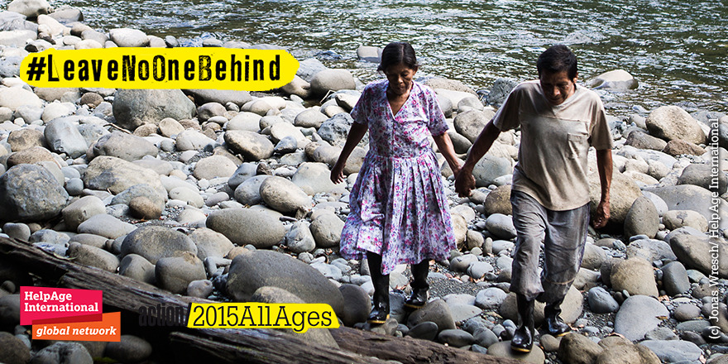
Dear friends,

I am writing to inform the HelpAge global network about the action/2015 campaign and an exciting Action All Ages day taking place on Friday 22 May.

The action/2015 campaign is a worldwide coalition united by the idea that 2015 presents a real opportunity to change our future. The HelpAge global network has joined to call on governments to commit to end poverty, address inequality and ensure sustainable development. Our HelpAge specific call builds on our post-2015 work to ensure the Sustainable Development Goals (SDGs) are inclusive of people of all ages.

Throughout May, action/2015 are organising thematic days of action to mobilise 15 million people across the world, to put mass pressure on world leaders as they make final preparations for the Sustainable Development Goals (SDGs). As part of the mobilisation, we have organised an Action All Ages day on 22 May. The day will focus on youth and older people and call for people of all ages to be included in the post-2015 framework, so that it truly meets its objective to “leave no one behind.”

We are excited to announce that Desmond Tutu has pre-recorded a special message for world leaders calling for “all ages” inclusion in the new framework that will be released on the day. Ten network partners will take action organising intergenerational events on the ground and there will be a huge social media campaign to raise awareness about the need for people of all ages to be included in the goals.

I hope we can come together as a network to support this campaign and to spread the message that people of all ages must be included in the new Sustainable Development Goals.

What will be happening on the day?
- Desmond Tutu’s video will be released http://bit.ly/1IjA0Yk which will go live 00:00 GMT on 22 May
- Ten countries will be taking part in intergenerational campaign actions including; Malawi, Kenya, Mongolia, Zimbabwe, South Africa, Philippines, Vietnam, Thailand and Myanmar. Older people are connecting with younger people on the day to make the day truly intergenerational.
- We have organised a thunderclap sharing Tutu’s video – which you can sign up to now http://thndr.it/1cqfTdq
- We will be promoting the action/2015 music video created by our amazing team in Kenya - http://bit.ly/1JtHZ2m
- We will be sending out an international press release

How can the network get involved and take action?
- Join the Action All Ages Day by signing up to our Thunderclap campaign! A Thunderclap is a social media tool that sends a tweet from a group of people all at the same time. It’s like an "online flash mob."
- Share the Desmond Tutu video on Facebook and Twitter http://bit.ly/1IjA0Yk
- Share the Kenya action/2015 song - http://bit.ly/1JtHZ2m
- Share our intergenerational graphics through social media https://helpage.box.com/s/2hhhpoh17ahe5jeqzfxwq1pwkpr0nx8q

Example tweets:
- Join #actionallages day @ThunderclapIt calling for #SDGs to include voices of young & older people! #action2015 http://thndr.it/1cqfTdq
- SDGs must include voices of young and older people. Watch @TheDesmondTutu talk about #actionallages http://bit.ly/1IjA0Yk
- Older people 12% of global population. Don’t exclude them from SDGs. Find out how to get involved in #actionallages http://bit.ly/1AlXOFA

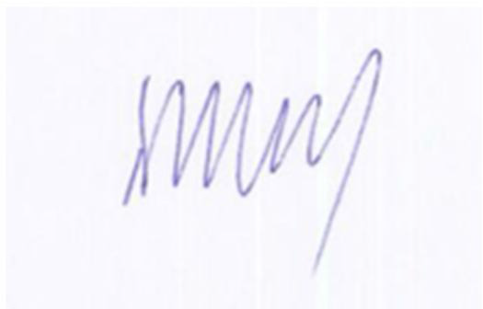
Toby Porter
Chief Executive of HelpAge International

