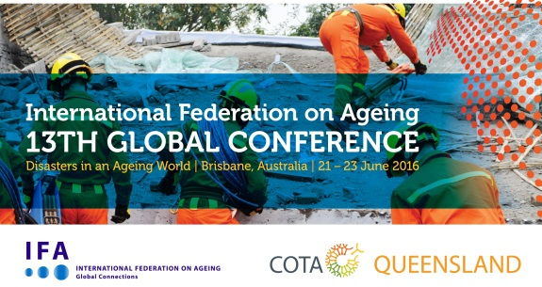

The International Federation on Ageing (IFA) 13th Global Conference on Ageing will be a seminal event that enables decision makers, practitioners, researchers, service providers, and community members to share their experiences to support rapidly ageing populations worldwide. The Conference will be among the first to take place after the conclusion of the post-2015 Development Goals and the revision of the Hyogo Framework for Action on Disaster Reduction.

The central theme of the 13th IFA Conference will be on natural and human-induced disasters and health emergencies in an ageing world in a program that will explore approaches to risk reduction (e.g. mass gatherings), readiness, resilience, response and recovery with the goal of understanding how to establish and design more age friendly, disaster prepared communities. While there is a focus on disasters in an ageing world the conference will cover the broad range of age related issues. See the full range of tracks and themes by visiting the conference website.

Learn more at www.ifa2016.org.au

