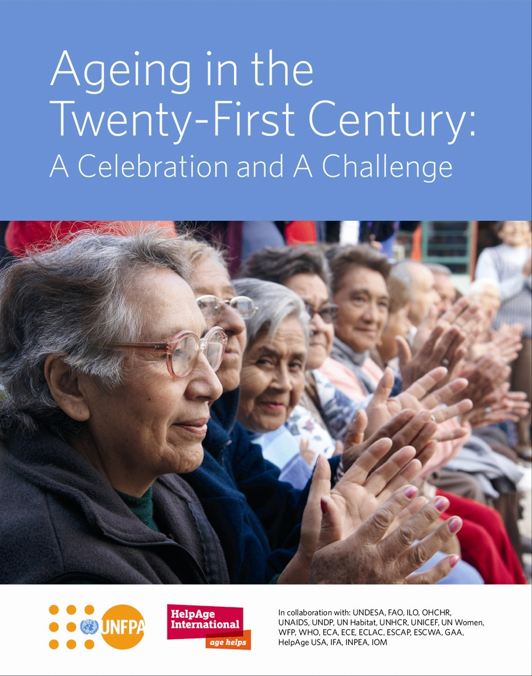

**HELPAGE GLOBAL NETWORK – UPDATE 1**

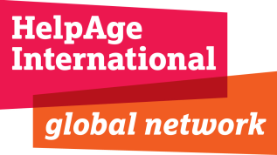

Dear Colleague,

I am so proud and happy to hear about all the great work and effort that is going into making the launch of ***Ageing in the Twenty-First Century: A Celebration and A Challenge*** a huge success across the HelpAge network.

Whether you are an **ADA** campaigner, Affiliate, Regional Development Centre or Country Office, it is clear this landmark publication is going to stimulate debate and action on population ageing, one of the most significant trends for the 21st century which is affecting all countries at all stages of development.

To follow up from your previous communication please find enclosed more tools to use for external communication:

* Update on Distribution and Translation
* Key messages (for use with both **Age Demands Action** (**ADA**) and non-ADA activity)
* Global press release (and guidance on how to nationalise and connect to **ADA**)
* Electronic flyer
* Q and A

You will also find attached to this email a background document which includes the following:

* Our HelpAge Goals for Ageing in 21st Century
* HelpAge Talking Points – with evidence
* Country specific examples to draw on

**Embargo agreement**

Once again, please note that the publication of the news story and report is **embargoed until1 October 2012.** This means that no third parties, except trusted stakeholders, should publish until then.

Globally, the report will be launched in Japan through a press conference with UNFPA and HelpAge International, followed by coverage around the world from your office or organisation – supported by **ADA** activity where applicable. This media embargo must not be broken before then – we hope you understand this is critically important.

**Thank you**

As ever, our teams in your region and London are here to support you in every way possible, please do not hesitate to contact them.

Good luck and here is to a great October 1,

Richard Blewitt, CEO, HelpAge International

**UPDATE ON DISTRIBUTION**

Copies of the full report and executive summary have now left the printers and are on their way to you. They will reach you next week.

**UPDATE ON TRANSLATION**

The executive summary is being translated into Arabic, Chinese, French, Japanese, Portuguese, Russian, Spanish and Vietnamese. It will be available as a PDF in these languages for you to print out in your office or take to a local printer. If you need a PDF in any of these languages, please contact Celia Till Email: [ctill@helpage.org](mailto:ctill@helpage.org)

**E-FLYER**

Please find attached to this email an ‘e-friendly’ flyer that you can adapt and circulate to contacts and stakeholders who may be interested in the report and its findings. We advise sending this first thing on **Monday 24 September**.

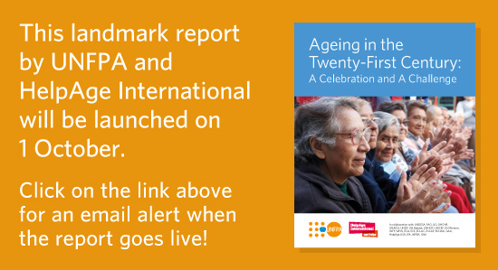

**KEY MESSAGES**

The joint key messages between HelpAge International and UNFPA for the report external communication are as follows (*20 September*). Please use these as a guide for all external press releases, interviews and media engagement. We 100% support and promote regional or national interpretations of the report, but would encourage you to ensure the following messages are incorporated in your material. Please also refer to the background paper for any further help on HelpAge specific positioning:

1. **The world is quickly becoming much older.** 
   * Within only 10 years, there will be one billion older persons worldwide.
   * This unprecedented silent revolution of population ageing is happening everywhere but is progressing faster in developing countries: by 2050, nearly 80% of the world’s older persons will live in developing countries.
2. **Population ageing is both an opportunity and a major challenge.** 
   * The demographic shift is a triumph of development that presents endless opportunities: harnessing the contributions a socially and economically active, secure and health ageing population can bring to societies will be key.
   * Still, population ageing also means an increasing demand for income security, health and long-term care, which creates huge social, economic and cultural challenges that will need to be addressed with strong political will and appropriate policies.
3. **Urgent action around population ageing will be needed to leverage the opportunities and overcome the challenges.**
   * Everyone must be involved, including governments, civil society, communities, families and older persons themselves.
   * All must develop a new culture in which older persons are considered active members of their society and their contributions and rights are recognized and promoted.

**GLOBAL PRESS RELEASE**

The below press release is the global announcement/news story that will be issued from Japan through Portland communications on behalf of UNFPA and HelpAge.

Please use this as guidance to produce your own national press release – do borrow or lift language and text you feel useful and keep your communication in line with the key messages, as above.

If you are located in the Global North and require a similar global story, we encourage you to use the same release with small tweaks as closely as possible.

**When to issue this?**

* It is recommended to offer your most important outlets **embargoed** copies of the report and 1 week in advance of the report launch and embargoed copies of the press release 48 hours ahead of the report launch **on Friday 28**.
* For broadcast outlets, offer embargoed copies of the press release and report 1 week in advance.
* Finally, send out the general press release, with clear embargo details **(below in red)**, on **Monday 1** – you may wish to send this on **Sunday** so it arrives with journalists on time.

**ADVANCED PRESS RELEASE**

**NOT FOR PUBLICATION BEFORE 01.00 HOURS UTC/GMT, 1 OCTOBER.**

**Population of over 60 year-olds to reach one billion within the decade,**

**finds new UN Report**

**Report Calls for Urgent Action by Governments to Address the needs of the “Greying Generation”**

* 80% of world’s older people will live in developing countries by 2050
* Over 60 population will be larger than the under-15 population in 2050

**Tokyo, 1 October 2012—** The number of older persons is growing faster than any other age group, says a new report,*Ageing in the Twenty-first Century: A Celebration and a Challenge*, released today on International Day of Older Persons by UNFPA, the United Nations Population Fund, and HelpAge International.

The new report underlines that, while the trend of ageing societies is a cause for celebration, it also presents huge challenges as it requires completely new approaches to health care, retirement, living arrangements and intergenerational relations.

In 2000, for the first time in history, there were more people over 60 than children below 5. By 2050, the older generation will be larger than the under-15 population. In just 10 years, the number of older persons will surpass 1 billion people — an increase of close to 200 million people over the decade. Today two out of three people aged 60 or over, live in developing and emerging economies. By 2050, this will rise to nearly four in five.

If not addressed promptly, the consequences of these issues are likely to take unprepared countries by surprise. In many developing countries with large populations of young people, for example, the challenge is that governments have not put policies and practices in place to support their current older populations or made enough preparations for 2050.

Speaking at the report’s launch in Tokyo, UNFPA Executive Director, Dr. Babatunde Osotimehin, said: “People everywhere must age with dignity and security, enjoying life through the full realization of all human rights and fundamental freedoms.”

“Longer life expectancy,” he added, “was a goal of the Cairo International Conference on Population Development in 1994. More action needs to be taken to achieve this for all people; new poverty goals must not exclude older people.”

Important progress has been made by many countries in adopting new policies, strategies, plans andlaws on ageing, according to the report. For example over 100 countries in the last decade have put in place non-contributory social pensions, in recognition of old age poverty. But much more needs to be done to fulfil the potentialof our ageing world.

Forty-seven per cent of older men and nearly 24 per cent of older women participate in the labour force. Yet, despite the contributions that a socially and economically active, secure and healthy ageing population can give to society, the report also notes that many older persons all over the world face continued discrimination, abuse and violence. The report calls for governments, civil society and the general public to work together to end these destructive practices and to invest in older people.

The report also includes the stories of 1,300 older men and women who participated in group discussions in 36 countries around the world. Their first-hand accounts and testimonies add the perspectives of the older population supporting efforts for better understanding and immediate action to meet their needs.

Richard Blewitt, Chief Executive Officer of HelpAge International, said: “We must commit to ending the widespread mismanagement of ageing. Concrete, cost effective advances will come from ensuring age investment begins at birth - fully recognizing the vast majority of people will live into old age. Global and national action plans are needed to create a pathway to transform the explosive number of people over 60 to become growth drivers and value creators. By revolutionizing our approach and investing in people as they age we can build stronger, wealthier societies. Social protection and age friendly health care are essential to extend the independence of healthy older people and prevent impoverishment in old age.”

“These actions,” added Mr. Blewitt, “should be based on a long-term vision, and supported by a strong political commitment and a secured budget.”

“Ageing is a lifelong process that does not start at age 60. Today’s young people will be part of the 2 billion-strong population of older persons in 2050,” said Dr. Osotimehin. “This report shows that, with actions taken now, we can all benefit from the longevity dividend– increasingly in the developing world - now and in the future.”

***

**Notes to Editors**

**Contacts:** Mandy Kibel, UNFPA, +1 212 297 5293, [kibel@unfpa.org](mailto:kibel@unfpa.org); Omar Gharzeddine, UNFPA, +1 212 297 5028, [gharzeddine@unfpa.org](mailto:gharzeddine@unfpa.org) and Meg Rowley, +1 212 541 2481, meg.rowley@portland-communications.com

Rachel Trayner, HelpAge, +44 (0) 207 148 7623, +44 77 3898 2122, rtrayner@helpage.org

UNFPA, the United Nations Population Fund, is an international development agency delivering a world where every pregnancy is wanted, every childbirth is safe and every young person’s potential is fulfilled.

Help Age International, helps older people claim their rights, challenge discrimination and overcome poverty, so that they can lead dignified, secure, active and healthy lives.

Today, UNFPA and HelpAge are hosting high-profile press conferences and a symposium in Tokyo. These events will be followed by similar launches around the world.

Today’s global launch will be followed by a day of global activism in which more than 60,000 older persons aged 60 or over, from 60 countries, will be campaigning as part of Age Demands Action (ADA). This global grassroots campaign calls on governments, the international community and civil society to address the rights, concerns and needs of older persons.

**60 over 60**:To celebrate the release of a new report, [Ageing in the Twenty-first Century: A Celebration and a Challenge](http://www.unfpa.org/ageing21), UNFPA and HelpAge International are creating a list of 60 inspiring and influential older people over 60, and we need your help.

**Make your nominations for 60 over 60 now!**

You can nominate yourself, or an older person you admire, beginning today. We are looking for a diverse group representing many nationalities and ages.

There are 3 ways you can nominate your inspiring older person for the 60 over 60 list:

* Visit [www.7billionactions/60over60](http://www.7billionactions/60over60) to submit a photo and short story, telling us in 150 words or less about the nominee’s accomplishments and qualities.
* Post an image to the [UNFPA](http://www.facebook.com/pages/UNFPA-United-Nations-Population-Fund/16322678622) or [HelpAge](http://www.facebook.com/HelpAgeInternational)’s Facebook wall with a short text of 100 words or less.
* Share a tweet of 140 characters or less, using the #60over60 hashtag

**Nominations will close on 23 November 2012.**

All qualifying nominees will be posted on the 60 over 60 webpage of the 7 Billion Actions platform. An expert panel of respected public figures working with older people, or older people themselves, will narrow the list down to 60 people. The panel’s selections will be announced in December.

**ENDS**

**How do I make the press release local?**

For those of you with a national story to tell or **ADA** campaign to connect, please refer to the local guide we issued in the first toolkit, repeated here again for your guidance. We encourage you to use your **national** story and **local campaign** in connection to the report.

**OPTION ONE: Age Demands Action**

**ADA** and the report work hand in hand. If your country has an **ADA** activity planned, you can use the report to highlight the importance of your ask – it gives you more power when speaking to the media or politicians – this is the local story behind the global numbers. If you are in a country without **ADA** activity you can talk about being part of the global movement:

Key message to use:

**“Over 60,000 older people over 60, from over 60 countries will demand their voice is heard through Age Demands Action.”**

This year, **more than ever**, thanks to the ten-year anniversary of MIPAA and this report, **ADA**, from the local to international level, will be able to generate **new** and **live** debate on the issue of population ageing.

To get **ADA**, **your** campaign and **your** voice, into the media (and influence opinion formers and politicians) you need to make sure you say exactly **WHAT** is going on, e.g. campaign action and **WHY** this is happening – that will help to engage the audience.

Please edit the **Notes to Editor** to include:

* Age Demands Action is the first global campaign of its kind, launched in 2007 by **HelpAge International**, the global network fighting for the rights of older people. Visit <http://www.helpage.org/get-involved/campaigns/age-demands-action/>
* Age Demands Action is supported by figures such as Archbishop Desmond Tutu; the Archbishop of Canterbury, Dr. Rowan Williams; Sarah Obama, the step-grandmother of President Barack Obama; and Prof. Miriam Were, the Hideyo Noguchi Africa prize laureate.
* People can say no to age discrimination and support the Age Demands Action campaign by signing an open petition at <http://www.helpage.org/get-involved/campaigns/age-demands-action/sign-the-ada-petition/>
* Your spokesperson, your contact details and telephone number

**OPTION TWO: Regional Chapter**

The report consists of recent data and analysis on all world regions and various countries. We have an entire chapter (**Chapter 3**) dedicated to these regions - you can find region/country-specific data and information in this section. The chapter also highlights progress and identifies gaps in forming and implementing various policies on ageing in the region. Also, the report is rich with facts and figures that could be relevant to your region or country (**in particular, Appendix 1**).

We strongly encourage you to read the report, particularly **Chapter 3**,and pull out statistical evidences on your country to have your own national factsheet (**see action three**). This will provide you with evidence to back up your media-related works.

**OPTION THREE: Global Factsheet**

Along with the report, we have an Executive Summary and a global fact-sheet (**see Executive Summary**). The fact-sheet consists of up-to-date statistical data and figures on global trends in population ageing. It provides a global picture of issues concerning older persons by providing evidence on health, income security and rapid demographic shifts. It also provides a glimpse into the voices of older persons who took part in the consultations for this report. For those who need a global story – please use this, for those who require a national fact-sheet please refer to this as a helpful guide and develop a National Factsheet.

**OPTION FOUR: National Factsheets (previously called report cards)**The AgeWatch (report card) for your country provides key data on population ageing in your country. Each country’s AgeWatch provides the latest statistics on life expectancy at birth and at age 60 and healthy life expectancy visually presented in barometers, showing how your country fares in comparison to other countries. Pie charts will further show the percentage of the population aged 60 and 80 over and information on policies, legislation and social pensions in your country will be provided wherever available.

This data will be available on the Global AgeWatch web portal-to download and print off – both for the media, meetings and events. You can use this to amend the statistics used above in the global release and make them relevant for you. If you can also use outputs from the Voices consultations if you participated in this research which makes up chapter 4 of the report.

In addition to the national AgeWatch there will also be rankings of life expectancy at 60 and healthy life expectancy at birth by country showing where your country stands in comparison to others.

**The National Factsheets will be available online by Wednesday 26 at** [**www.globalagewatch.org**](http://www.globalagewatch.org)**.**

**60 over 60: A Call for Nominations of Outstanding Older People**

**Help us showcase inspiring people over 60.**

Perceptions of the world’s “age burden” are outdated. Older people can be athletes, statesmen, innovators, entrepreneurs, caregivers, activists.

They can teach, inspire, influence, lead, innovate and create. As longevity increases and health improves, older people can contribute more to society than ever before.

And their contributions will become increasingly important as the world grows older – a phenomenon that is happening in nearly every country and every region.

Here are just a few examples:

* 106-year-old Saburo Schohi from Japan is the oldest person to travel around the world using public transport.
* 78-year-old Mama Rhoda from Kenya is an [Age Demands Action](http://www.agedemandsaction.org) campaigner and award-winning community worker. She represents her fellow older Kenyans at Government level.
* And of course, 94-year-old Nelson Mandela, Former President of South Africa, Nobel Peace Laureate, and founder of the Elders – a group of global leaders working together for peace and human rights.

**Make your nominations for 60 over 60 now!**

To complement the release of a new report, [Ageing in the Twenty-first Century: A Celebration and a Challenge](http://www.unfpa.org/ageing21), UNFPA and HelpAge International are creating a list of 60 inspiring and influential older people over 60, and we need your help.

You can nominate yourself, or an older person you admire, beginning today. We are looking for a diverse group representing many nationalities and ages.

From **Monday 24 September**, there are 3 ways you can nominate your inspiring older person for the 60 over 60 list:

* Visit [www.7billionactions/60over60](http://www.7billionactions/60over60) to submit a photo and short story, telling us in 150 words or less about the nominee’s accomplishments and qualities.
* Post an image to the [UNFPA](http://www.facebook.com/pages/UNFPA-United-Nations-Population-Fund/16322678622) or [HelpAge](http://www.facebook.com/HelpAgeInternational)’s Facebook wall with a short text of 100 words or less.
* Share a tweet of 140 characters or less, using the #60over60 hashtag

**Nominations will close on 23 November 2012.**

All qualifying nominees will be posted on the 60 over 60 webpage of the 7 Billion Actions platform.

An expert panel of respected public figures working with older people, or older people themselves, will narrow the list down to 60 people.

The panel’s selections will be announced in December and the 60 over 60 list will be featured online and in the media.

**Q AND A**

Please find below a Frequently Asked Question (FAQ) sheet.  This is for HelpAge staff and speakers presenting the report.  Please feel free to use your own local knowledge to add examples and relate questions to your local context. The text in **red** is a choice of sound bites you should try and use.

Also attached to this toolkit is a more detailed background paper focused on HelpAge goals, talking points and examples of HelpAge projects you can draw on.

**Ageing in 21 Century: FAQ – HelpAge International**

**Why did UNFPA and HelpAge International undertake this report?**

To chart progress, ten years on from the *Madrid International Plan of Action on Ageing.* “Ageing in the 21st Century” is the culmination of a three year collaboration between UNFPA and HelpAge International with contributions from United Nations agencies, United Nations Regional Commissions.  The report uses fresh and in-depth evidence to provide detailed policy guidance building on the recommendations of the Madrid Plan.  At its heart 1,300 older people from 36 countries share their opinions. From all contributors, an urgent and compelling case is put forward for an increase in the prominence of ageing in public policy and budgets

**What is the subject of the new report?**

The report analyses the current situation of older persons and reviews policies and actions taken by governments and other stakeholders since the Second World Assembly on Ageing in 2002. The report highlights the major growth in proportions of older people particularly in emerging and developing economies between now and 2050. **The facts and figures presented in the report provide compelling evidence that existing economic and social contracts which focus on youth and middle age only, are outdated and unsustainable as population ageing defines this century.** Older people are increasingly main care givers of young dependents as the middle generation seeks work in increasingly insecure environments. Health, social protection and labour laws that support ageing are needed, new human rights instruments are required to protect us as we age and our attitude to ageing needs to shift as most of us will now live into older age.

The report identifies gaps and provides recommendations for the way forward to ensure a society for all ages in which both young and old are given the opportunity to contribute to development and share in its benefits.

Critically, the report calls for urgent attention to be focused on ageing in developing economies.

**Why is population ageing a priority for emerging and developing economies?**

**Because after years of viewing ageing only as a concern for developed economies, ageing is now on the point of going global**: nearly 80 per cent of the world’s older people will live in emerging and developing countries by mid-century.  Of the current 15 countries with more than 10 million older persons, seven are developing countries, including Bangladesh and Brazil.

Because today’s older people living in these countries have urgent concerns - particularly income security and access to affordable health care.  Current policies and practices, for example in health delivery and the workplace, often discriminate against older people; older people make up an increasing % of informal sector workers without protection; and issues such as the increasing numbers of older people who are bringing up children alone because of migration are not addressed.  Actions on these issues are essential to unlocking the potential of population ageing. **The continued mismanagement of ageing is NOT an option.** If not addressed there will be huge costs and consequences for older people and the social and economic and political fabric of countries.

Because already there are more older people than children under 5, and by 2030 there will be more people over 60 than under 10 years old. Those in the youth bulges of today will live well into older age and will constitute the major part of the population by 2050 in many countries. Investing in healthier, more active and more productive ageing now will support healthier as well as longer lives and give us the capacity to spend where necessary on those who need greater support in their later years.

Because on ethical and humanitarian grounds, changing attitudes and behavior to old age is the right thing to do, the fair thing to do and the just thing to do.  Older people have a fundamental human right to their share of resources which is cemented by the 1948 Universal Declaration of Human Rights.

We need to start investing in our growing, older populations through increased employment, business opportunities and pensions, supporting their roles as care givers to children, the oldest old and the sick, improving access to quality health care, particularly by increasing investment in the prevention and treatment of non-communicable diseases including dementia.

With the right measures in place to secure health care, regular income, and legal protection as we age, there is a "longevity dividend" to be reaped by current and future generations.

**As governments address ageing in their national plans what should be their priorities?**

**Countries that develop national economic, social and cultural plans for ageing are those that will be most successful.**  The continued mismanagement of global ageing is not an option, doing so would have huge financial and human costs. **New plans, laws and budgets are needed – priorities include:**

* Extend universal measures for social protection and old-age pension coverage especially where a large proportion of the labour force is found in the informal sector.
* Introduce flexible employment, lifelong learning, removal of forced retirement and retraining opportunities to enable people to continue working as they age in accordance with their capacity, experience and preference.
* Support communities and families to develop support systems which ensure that older persons are not isolated as they age and can also receive the long-term care they need.
* Support the development of international human rights instruments, such as a convention on the rights of older people
* Support national efforts to develop comparative research on ageing, and ensure that gender- and culture-sensitive data and evidence from this research are available to inform policymaking.
* Ensure the inclusion of older people in national development and humanitarian response and that the post 2015 framework is age inclusive.

**How many people around the world are over 60?**

Today – 810 million

By end of the decade (2020) – 1 billion

2050   - 2 billion

**How many people around the world are over 80?**

Today – 114 million

2050   - 402 million

**How rapid is the growth of ageing societies?**

In 2000 there were more people over 60 than children under 5

By 2030 (end of next MDG’s) there will be more people over 60 than children under 10

By 2050 there will be more people over 60 than children under 15

**Are high and low income nations affected similarly?**

HelpAge’s experience is in low income countries. **Older persons make massive contributions to the society– as mediators, educators, workers, volunteers, homemakers, caregivers and a source of knowledge, historical memory and guardians of culture.** Increasingly, older generations are becoming active in political processes, forming their own organizations and campaigning for change.

However many people in low income nations will get old before they get rich. More people in low income countries are ageing in poverty without pensions, health or social care and very limited access to basic services.  The demographic impacts of issues such as migration, urbanization and HIV have seen the role of older people in some regions and sectors shift dramatically to be key care givers.

The impacts of these trends on a range of development issues from family structures, health systems and food supply are already being seen. However, the response by governments in low income countries and the international community is commonly weak, with many not taking action to respond rapid demographic changes and the issues facing an increasing population of older people.

**What additional challenges do low and middle income countries face when making ageing a national priority?**

Important examples include:

* Older people, particularly older women are particularly vulnerable to continuing widespread poverty and growing inequality.
* Non Communicable diseases which already impact on older people more severely than the general population are set to increase.
* More frequent and intense climate related and humanitarian disasters in future decades are set to hit increasingly ageing populations.
* Many countries are seeing an ageing of the farming workforce unless these farmers are supported e.g. with training, access to credit and new technology there could be major implications for future food supply and land management.
* There is limited data relating to older age, making the world effectively blind to the issues of older people and the implications of a growing older population.

**How should population ageing be addressed in post-2015 agenda?**

**The post-2015 development agenda should incorporate goals, targets and indicators that are responsive to different stages of the life course** and, where relevant, specifically relate to older age by

* Integrating a target on life expectancy at birth as a measure of human development for all ages.
* Adopting the approach of social protection floors to guide countries in extending social protection systems and as a way of measuring progress.
* Including targets to improve healthy life expectancy to reduce the time people spend in ill health.

**What is HelpAge doing in response?**

The HelpAge International network is committed to helping older people live full and secure lives. We work with more than 180 partners in over 70 countries across the world.  Direct service provision, practical support, research and evidence gathering and training are central to our work. **We provide assistance to more than a million older people and their families each year and we draw on this experience to influence other service providers, indirectly reaching millions more.**

We also highlight the right of older men and women to a secure income and appropriate healthcare, and we show how this benefits not only older people themselves, but also wider society, especially their grandchildren. And we continue to stress how older people’s human rights are violated, simply because of their age.

Responding to the needs of older men and women in emergencies is a particular priority. In emergencies, older men and women are some of the most vulnerable due to age-related concerns. As well as assisting older people in our own emergency programmes, HelpAge works closely with national and international humanitarian actors to influence policy and practice to ensure the specific needs of older people are addressed.

***We will be in touch again early next week with more digital support. Best of luck to everyone and let’s look forward to a successful 1 October!***

***The Ageing in 21st Century Team.***